**B) Digital Artwork Guideline Checklist**

Here are the basics to have in place before submitting your digital artwork:

Artwork should be saved as JPEG, TIFF, EPS, or MS Office (DOC, PPT, XLS) files. High

resolution PDF files are also acceptable.

Crop out any white or black space surrounding the image.

Please use either Arial or Helvetica font size 7 for any text or labels within illustrations.

Diagrams, drawings, graphs, and other line art must be vector or saved at a resolution

of at least 1200 dpi. If created in an MS Office program, send the native (DOC, PPT,

XLS) file.

Photographs, radiographs and other halftone images must be saved at a resolution of at

least 300 dpi.

Photographs and radiographs with text must be saved as postscript or at a resolution of

at least 600 dpi.

Each figure must be saved and submitted as a separate file. Figures should not be

embedded in the manuscript text file.

**Fig.1**

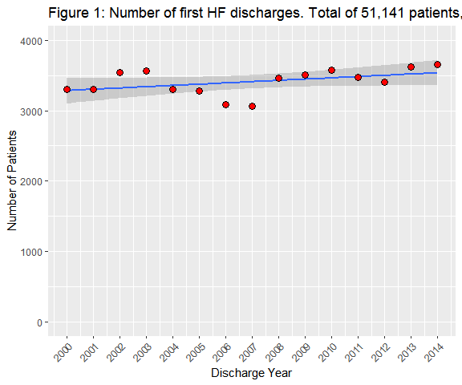

**Fig.2** ***UPDATE THIS FIGURE***

Fig.3

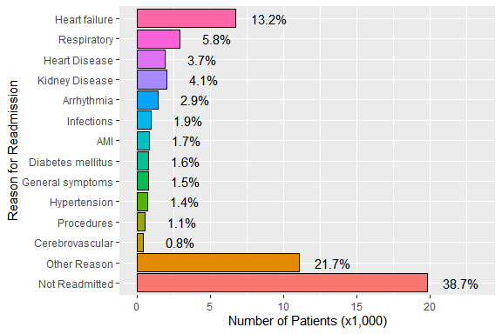

Fig.4

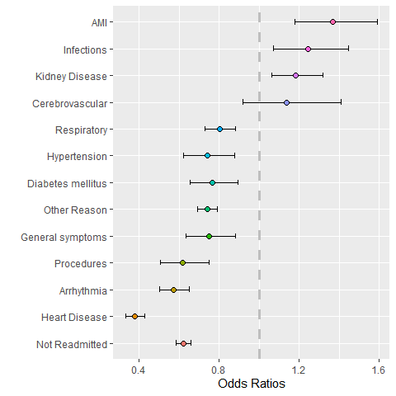

**Fig.5**

